NAME: __________________________________
Chapter 11.1.1 – The Rise of Nazi Power
Directions: Read “Hitler and Nazi Germany” on pp266, then address the following:
1. Why might Hitler, a German, have been angry at his own government after the end of World War I? ________________________________________________________________________________________
2. According to the text, what were the three main goals of the Nazi party in Germany?
__________________________________________________________________________________
__________________________________________________________________________________
__________________________________________________________________________________
3. In what ways is Hitler’s rise to power in Germany from today’s class similar to Mussolini’s rise to power in Italy from yesterday’s class? (At least TWO reasons!)
__________________________________________________________________________________
__________________________________________________________________________________
__________________________________________________________________________________
Cornell Notes Mini-Lecture: Hitler and the Rise of Nazism
CONTEXT: For the last two days, we have discussed and witnessed the rise of dictatorial and totalitarian regimes in Europe. In many cases, these dictators are elected into positions from which they later grab more and more power for themselves. Without the initial support of at least some sizeable group of voters, these parties could never have seized power.
Document #1 : German Unemployment Rate (In Millions)
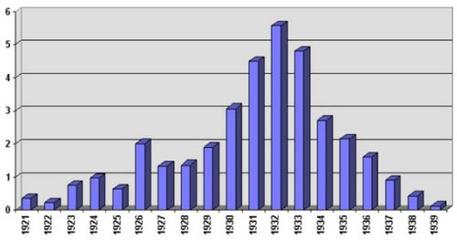
Document #2 : German Government Election Results, 1930
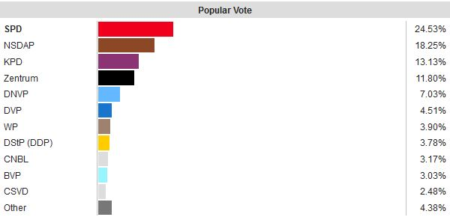
Why might voters during this time period be attracted to authoritarian and totalitarian rulers enough to vote for them? Use the two attached documents as evidence to support your answer. (1 Paragraph)
_________________________________________________________________________________________________________________________________________________________________________________________________________________________________________________________________________________
_________________________________________________________________________________________________________________________________________________________________________________________________________________________________________________________________________________
_____________________________________________________________________________________________________________________________________________________________________________________
__________________________________________________________________________________________

